-- \*\*\*\*\*\*\*\*\*\*\*\*\*\*\*\*\*\*\*\*\*\*\*

-- Name: Wei-Chih Kao

-- ID: 158000190

-- Date: Oct.12.2021

-- Purpose: Assignment1 DBS311 NEE

-- \*\*\*\*\*\*\*\*\*\*\*\*\*\*\*\*\*\*\*\*\*\*\*

-- Question 1 –-

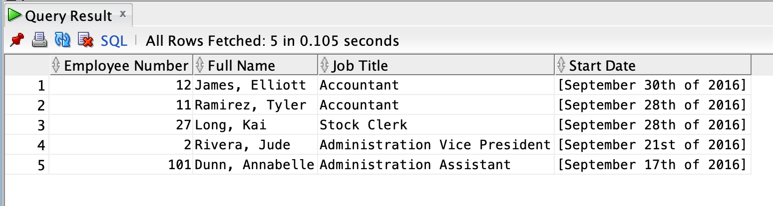

-- Question 2 –-

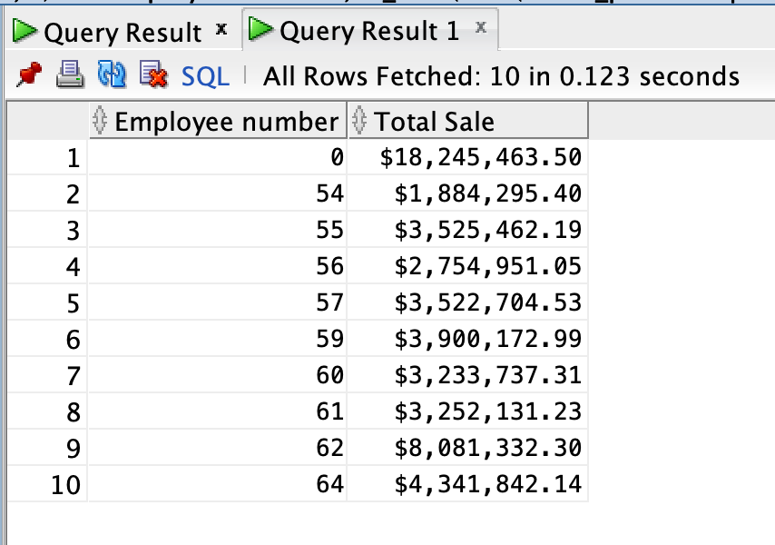

-- Question 3 –-

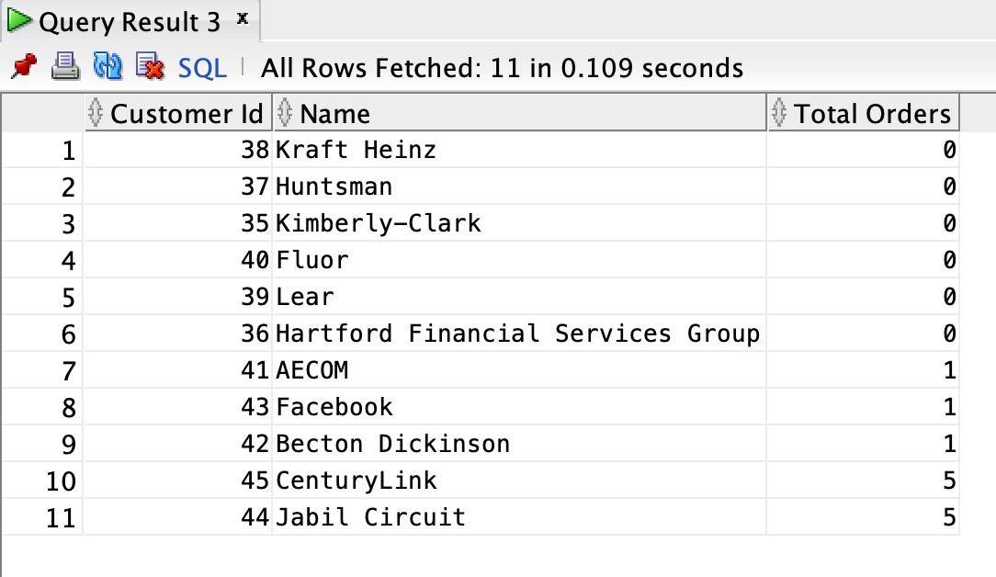

-- Question 4 –-

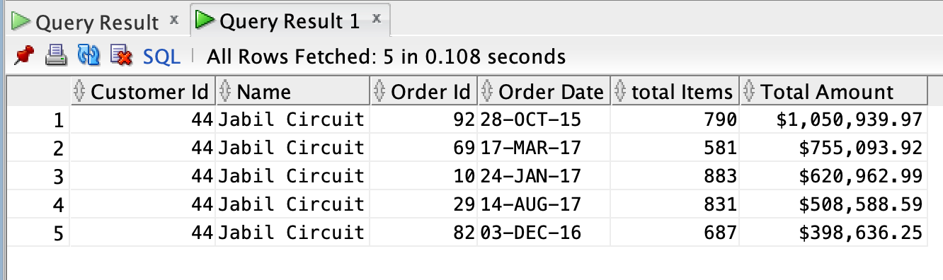

-- Question 5 –-

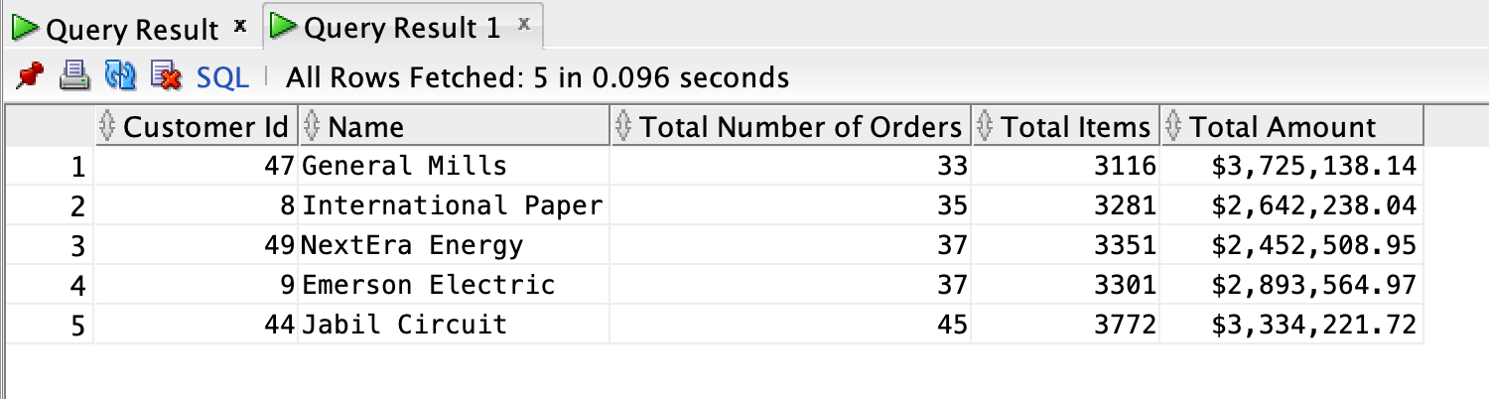

-- Question 6 –-

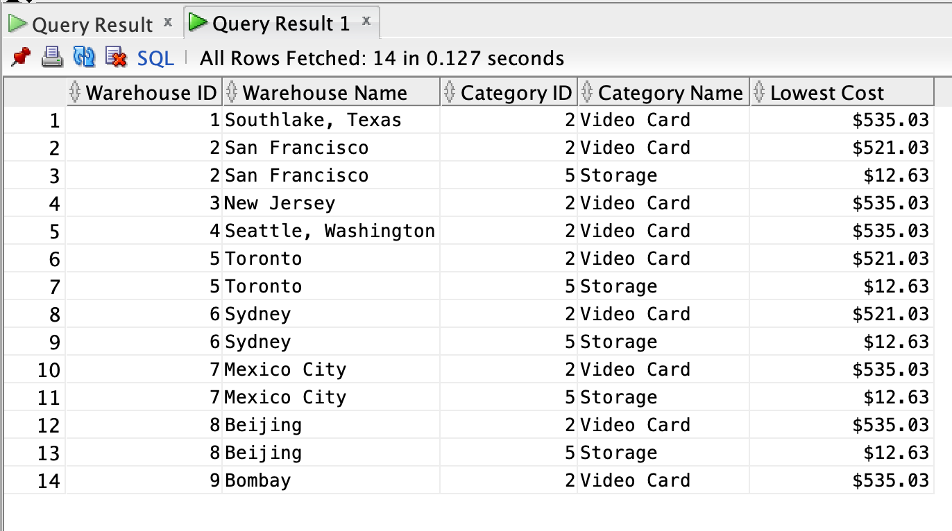

-- Question 7 –-

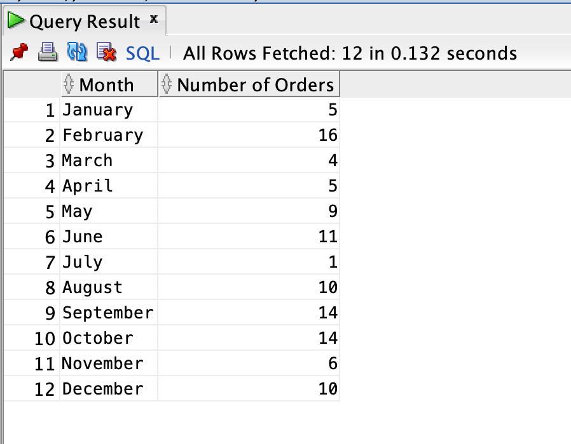

-- Question 8 –-

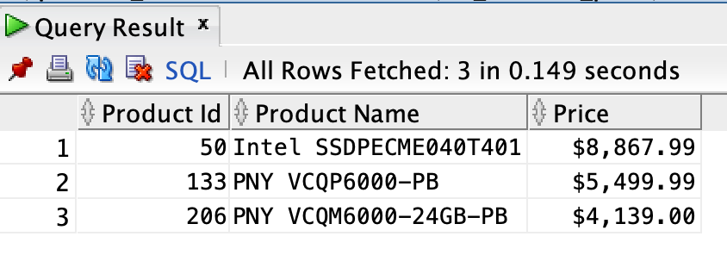

-- Question 9 –-

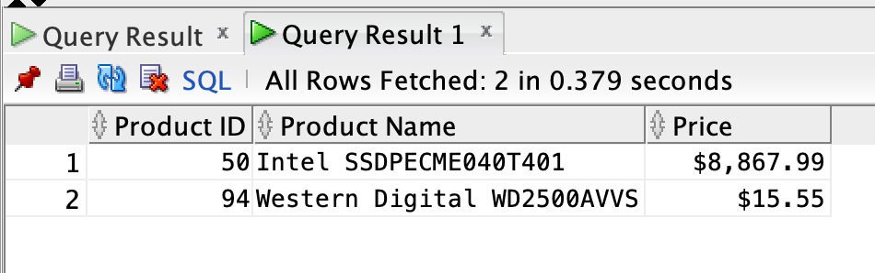

-- Question 10 –-

